Chapter 10, Solution 77.

Consider the circuit below.
-
+
R₃
V₁
V₁
R₁
R₂
C₂
C₁
+
V_{o}
-
V_{S}
+
-
2
1

At node 1,
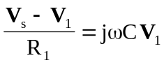
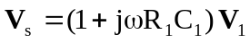 (1)

At node 2,
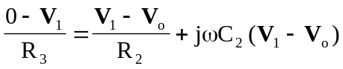
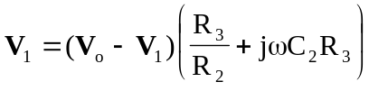
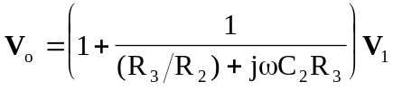 (2)

From (1) and (2),
